Anup Pokherl

The british college  Thapa thali, Kathmandu

Student Id: 77193454

Username: c7193454

Online examination system

**Acknowledgement**

I would like to give a special thanks to my teacher DR. Pranita Upadhyay to give me this opportunity to do this project on the topic “Online Examination system”. She gave me a suggestion for the project and help me to co-ordinate my project.

I would also like to thankful for all other people who help me in this project by giving their feedback. Teacher and students of The British college. This project gives me an idea about to do research and developed a web-based application.

**Abstract**

Online examination system is an application software which is use to conduct examination via online environment. Examination can take by any educational institutes by using internet or local area network. It is a web-based application which is considered as a fastest method of examination system.

Online examination system is cost effective than manual examination system or paper-based examination system. To conduct manual examination system, we need separate examination hall. we need more invigilator to take exam and need more resources to make questions for exam. Manual examination system takes a longer time to published a result. There is high chance of loss of records and data. Searching of loss records take more time. It needs more human resources to maintain the data and records. Online examination system required less human resource to conduct the examination. It helps to diminishing the need of question and answer paper in the exam. Student also get more time in the exam. It also helps to educational institutes to evaluate and analyzed the progress of their student easily. Online examination system checks the answers automatically and published result immediately. It makes easy for organizations to prepared a question for exam. Questions can store in the database and randomly generate for the exam. It saves time, cost and effort. Online examination system is the important part of online education. Student can give exam from anywhere through the internet.

This web-application is developed using PHP programming language. Front-end of the application is developed by using HTML, CSS, bootstrap and JavaScript. Agile software development methodology model is followed to developed the application. MySQL I database server is used as a database which is the extended version of MySQL. Microsoft Visio is used to design the different diagrams of system. This report describes the main principals and functions of the system. Algorithm of automatic result publishing, rank creating and total marks publishing are analyzed.

Contents

Chapter 1: Introduction 5

1.1 Background of study 5

1.2 Statement of the problem 5

1.3 Objectives 5

1.3.1 General objectives 5

1.3.2 Specific objectives 6

1.4 Research question 6

1.5 Rational 6

Chapter 2: Literature Review 7

Chapter 3: Review of Technology 11

Chapter 4: Methodology 14

4.1 Field visit 15

4.2 System Development Lifecycle 16

4.3 Gantt chart 16

Chapter 5: Design 19

5.1 Flow chart 20

5.2 Entity Relationship Diagram 21

5.3 Use case diagram 22

5.4 Data flow diagram 23

Chapter 6 Production Implementation and Testing 25

Chapter 7: Product evaluation and project management 32

Chapter 8: Summery and conclusion 34

8.1 Summery 34

8.2 Findings 34

8.3 Conclusion and Recommendation 35

Chapter 9: References 36

APPENDIX A: PROJECT PLAN 39

APPENDIX B: DETAILED FLOW CHART 49

APPENDIX C: EVIDENCE OF RESEARCH 52

APPENDIX D: EVIDENCE OF PROJECT MANAGEMENT 62

APPENDIX E: USER GUIDE 70

APPENDIX F: EVEIDENCE OF PRODUCT TESTING 72

APPENDIX G: PRESENTATION SLIDES 75

# Chapter 1: Introduction

Online examination is one of the fastest growing system throughout the world. It is software solution which helps to take the examination through online or with the help of local area network. Many educational institutions use online education system to evaluate the knowledge of the student due to its accuracy and time. Result of the examination can be published immediately after the exam so it more effective than traditional way of exam.

R. Hameed, Muna & Abdullatif, Firas. (2017). Online examination system is a web-based examination system where examinations are given online. Either through the internet or intranet using computer system. The main goal of this online examination system is to effectively evaluate the student thoroughly through a totally automated system that not only reduce the required time but also obtain fast and accurate results

## 1.1 Background of study

Traditional way of examination is practiced in all over the world for a long time which is more time consuming and less accurate. In this exam system student must give the writing exam in paper. Study of this project should focus on the disadvantage of paper writing examination system and how can we make the examination system more effective, secure and accurate.

## 1.2 Statement of the problem

The main problem of traditional way of examination system is it is time consuming and expensive. Educational institutes need to prepare a question and print all the question for each student in every exam. More human resource is needed to conduct an exam and check the paper of the exam. Publishing a result in time is always difficult in this examinational system. All the data of online examination saved in the database which makes easy to change the question and exam rule for the teacher.

Another major issue of this examination is checking the paper and give marks which is totally depend on the tutor. Sometimes human errors occurred while marking the paper of the student so, student get less mark rather than the actual mark. In some cases, student may be failed due to the human errors in checking of papers.

In this examination system there is high chance of leaked of question paper. Recently question of SEE exam is leaked in some part of our country. In past years the question of engineering and MBBS entrance exam are also leaked in our country. This incident shows us that this examination system is less secured and efficient.

## 1.3 Objectives

Objectives defines the main purpose of any projects. It gives a clear vision about the different tasks that need to be include in project.

Two types of objective that are used in this project to specific its work.

### 1.3.1 General objectives

General objectives of this project:

* To develop a web-based application.
* To develop an online examination system.
* To replace a paper-based examination system.

### 1.3.2 Specific objectives

Specific objectives of this projects are given below:

* To study about the Examination system in our country and the world.
* To learn and follow the principals of System development lifecycle.
* To design and developed a user-friendly web application system
* To allows a user to perform a CRUD function properly.
* To provide an easy way of examination services
* To increase usability and customer experience.
* To make the examination system more secured and accurate.
* To reduces the cost of service and human resources.
* To test the system and get knowledge about white box testing.
* To follow the Harvard referencing format for the documentation of the project.
* To documentation of the project.

## 1.4 Research question

* What kind of problems student face while giving writing exam on paper?
* What kind of problems teacher face while checking exam paper?
* What are the problems while publishing the result of paper-based exam?
* How much expensive to conduct paper-based examination?
* How can online examination system help in the progress of student?

# 1.5 Rational

Main motive to work on this project is to make the examination system more secured and effective. In Paper based exam system question are less secured there is high possibilities of question leak before exam but in online examination system question can be keep in secured way with the help of computer security system.

Many problems are seen in a traditional way of examination system which creates huge problem in the result of the student. This project helps to reduce the logistic cost of the exam. Paper base exam system needs an invigilator in an exam hall to run the exam but in online system we do not need an invigilator to conduct the exam. We can use auto surveillance mode to supervise the exam. Webcam and cc camera can used instead of invigilator.

Result processing of traditional exam system is manual which takes a lot of time. Online examination system helps to analysis a result in systematic way and published a result instantly. Student do not have to wait a result for a long time. Traditional exam system is not flexible errors in the question paper cannot found easily. It is difficult to change the mistake question in time and rearrange the question. Online examination system helps to changes a question in any time if any mistakes is found. In traditional exam system questions for all student are same but in online system we can set a different question for each student. So, student cannot cheat in the exam hall easily.

# Chapter 2: Literature Review

Technology is use in every sector in the world among them education is one sector where technology is used rapidly. Technology helps to make the learning process easy and effective. Now it is not only use for learning process it also uses for taking the examination and testing skills. Educational institutional uses Computerized examination system to examine the student knowledge. Business institutional use online examination to hire a new employee and for interview. Many researches had done on how the technology can be used to test the knowledge of the people.

Du Ploov (1997) one experiment on online examination is performed in 1997. Questions and answer were transmitted between the university and remote examination center. Student give the answer in free text style. Another experiment is done in early 1999. Student got question from web-sites and write the answer in word processor and upload in the website. Instructor check the answer and give marks. Student got their result via website. This is not the fully automatic online examination system. Student can cheat easily in such examination. Any error occurred in websites then student do not get question paper and cannot upload their answer.

Guzman and Conejo (2005) proposed a plan for a new online examination system SIETT. SIETT stands for System of Intelligent Evaluation using Tests for Tele-education. It is a web-based assessment method that supports multiple types of assessment methods. Classical test theory, response theory and computer adaptive testing are the assessment methods of SIETT. In this web-application teacher can create numbers of different questions for the assessment. Question can be subjective, objective, multiple choice questions and tasks question. Teacher can provide hints to the questions. Feedback can provide after the completing of assessment by the students.

At first SIETT is developed to do and check the assessment of master’s thesis. Main goal behind the development of SIETT is to replace the paper-based assessment system. Paper-based assessment system creates a huge problem while checking an assessment. It can be easily copied by others so; it is less secured. Sometime papers are missing and difficult to find it at that time student can be failed in the exam. In paper bases exam knowledge of student can only analyzed by the number they got but SIETT helps to analyze each student knowledge level. In SIETT teachers can ask a different question to each student according to the level of student knowledge level. Response from a student to a question is computed and analyzed. Teacher can provide a test questions to the student so, student can prepare for the final test. Mistakes done by the student is addressed and correct feedback is giver for each question. SIETT provide a result analyzer tool which help to analysis the performance of student in a test.

On the other side SIETT have some issues in resumption capability. System failure while answering the question creates a huge problem. Time period for such examination is limited therefore system failure interrupt student to give exam in time which can make them fail in such case student should give the re-exam. It does not have multi-instructor features which makes the system difficult to manage. Single person should handle tasks of administration, question maker and exam builder. It takes a lot of time to set the questions and set up the examination. SIETT does not allow for the random question selection and distribution. Instructor need to setup and select the question for the examination. Distribution of the questions is also done by the instructor.

Henke (2007) proposed another web-based examination system called WETAS (web-based Test, Examination and Assessment System). WETAS is not independent system it is designed to integrated with Learning Management System. It provides a facility of test and assessment. Test can be given by setting in remote area. It contains a task assembler which creates a task from selectable text file. It provides a features of Random question selection so, this system does not need any extra question makers. Questions stored in database can randomly generated for the student in exam time. Mainly WETAS is use for creating a new assessment by using text editors. It supports Pictures and graphics in the assessment which makes the assessment more understandable. WETAS does not have resumption capabilities error in the system compromised the exam and result of the student. It is also governed by single instructor which is time consuming and less effective.

(Xingbao Li and Yunming Wu 2007) proposed an online examination and evaluation system which is based on a Browser-server model. Logically this system is divided into four sections content-displaying layer, application-running layer, data-operating layer and database (Ling 2002). Content-displaying layer is the GUI of the system. Application-running layer helps to make a connection between user and database. Data-operating layer receive a request for data, carried out a data from database and send to application layer. It provides a sub-system function for both teacher and student. Teacher can add and stored a question in the database. This system provide can generate a random question, evaluate students result and analyze exam papers.

Ping Guo et al (2008) proposed an online examination system which is divided into two model Browser-server model and Client-server model. This system can generate a text question only. It can track the answering process of student and give the artificial marking. It helps to do Statistical analysis of each students by providing grade to them. It helps to reduce the work load of teachers and reduced the cost of examination. Examination taken from this system is more effective and fairer. The main problem of this system is any error occurred in database then the examination site and the computer of examination hall are affected. It does not ensure the recovery measure of database.

Sophal Chao and Reddy (2008) proposed an internet-based examination system. This system is very helpful for teacher to set and regulate the examination. It allows to share the information between different department of the institutions and with other intuitions. Other system does not allow to share information. It also provides a learning environment. Scalability issues is the main problem in this system.

Rashad (2010) proposed another web-app of online examination called Exam management system (EMS). It is useful for managing examination system from registration of student for exam to the result. EMS collect the answers from examine into one system. It provides the features of auto mark system where answers given by student are analyzed and marks are given. Result is carried out in grading system. Result is further processed to carried out the progress report of each student. EMS required multiple instructor to run and managed the system. It required administrator, exam builder and question builder. All these instructors have their own work in the system. Administrator control the system and managed the registration of the user. Question builder made the questions for the exam and exam builder managed the exam time. Improper co-ordination between exam builder and questions builder can cause in the examination. Question builder may make the questions that teachers do not teach in the class at that situation questions need to change. It does not have the features of random question selection. It needs question makers to make the questions and update in the database. EMS does not have the features of random question selection and distribution.

Vasupongayya (2010) proposed a new examination system known as interactive Examination Management System (iEMS). It is one of the most advanced examination systems which provides a multiple feature which others system does not provide. It supports multiple instructor which helps to manage the system easily. Random question distribution feature is available so, set of question can randomly distributed to the student during exam by the system. It supports Random choices distribution where if two students get same questions then the questions are sorted randomly. IEMS is not a web-based application it is an application-based application, so it is a platform dependent application. Application need to be developed for differently plate-form separately.

Sheshadri (2011) initiated another Examination System name called a web-based Online Non-choice-based Examination System (WONES). It is a Hybrid application that can performed some of its features during offline. File system of this application is integrated with device file system and webservers. This system is very useful to evaluate a huge amount data got from the examination. It has its own examination server which makes the system reliable and secured. It provides the features of Biometric Authentication which makes the system more secured. One-time authentication code is given to the student for login into the system to give the exam. Real-time monitoring System is provided so, system can monitor by the instructor all the time. Graph and formulae can add into the system which is useful for non-choice-based exam. WONES evaluate the result by using library of compactors and heuristic rules. Disadvantage of this system is it does not random question selection and choices distribution. Error occurred in one part of the system can damaged a whole system.

Arvind Singh, Niraj Shrike, Kiran Shette 2011: They propose a computer-based test system which evaluates the student knowledge by using the concept of online examination system. This system is customizable. User can customize the question formation according to their need. It checks the answer automatically and published the result.

Satav (2012) initiated a new web-based examination system called Structure Query Language Based Paperless Examination System (SBPES). Exam is taken in descriptive format in this system with the help of Structured Query language. This system requires a highly skilled manpower to manage who have knowledge about SQL. So, SBPES is more secured, reliable and efficient. System can be updated easily to increase the accessibility of the user. It supports a multi instructor and portability features but does not have the features of random question selection and distribution.

Raj (2012) initiated a National Online Examination System (NOES) which is hybrid-based application system. Large number of students can take part in the examination which is carried out by NOES. Huge amount of question of each subject can store in its database. It is one of the most powerful examination systems which is developed by using spring and Hibernate framework. It provides the features of dynamin question generation. Questions are selected from database by the instructor and system dynamically generate the set of question. Secured login and portability are others features. This system does not allow to generate a random choice distribution and multi instructor

Islam (2013) initiated a web-based application name called Online Examination System in Bangladesh Context (OESBC). This web-application is more adaptable and flexible because multiple choices questions are given to the student. Answers given by students are checked and marks obtained by student immediately stored in database. Student can get the result report immediately inform of general mark list it also gives the ranking of each student in that exam. It provides a feature of secured login, random question selection and multi instructor. Features like random question distribution and random choices distribution are not available.

Fagbola (2013) initiated a new web-based examination system CBTS which stands for Computer Based Test System (CBTS). This examination system provides different features to make the examination more flexible and adaptive. Questions are provided from the database to the student in exam. Answers are checked by the system automatically and report of result is published immediately. When exam time is finished question done student is submitting automatically. It provides the features of timing flexibility where some time can add if any problems occur in the system. CBTS is the combination of web-based and hybrid-based application. It is a platform dependent application, so it needs to be developed for different operating system independently which makes it expensive. Random question distribution and random choices features are missing.

Nor Shahida bt Mohd Jamail Abu Bakar and Md Sultan, Faculty of Computer Science and Technology, Selangor, Malaysia Exam plays an important role to evaluate the student’s performance. Good Quality of question paper in the exam is necessary for the institution. It helps to determine the quality of student of the institutions. Conducting examination is challenging for the institutions because the number of students is increasing. Preparing a good quality of question is next challenge. Most of the current examination system store the questions in the database. Here a question can arise how the system helps to generate a question automatically without duplication and repetition. This can be huge problem in examination system. If the system cannot minimize the repetition and duplication of question then the quality the examination is very low and evaluation of the quality of student could not happen effectively.

# Chapter 3: Review of Technology

Web based Online examination system is going to be developed in this project. Web based application is a software program which can be run by using a network connection called hypertext transfer protocol (HTTP). It uses a client server network for the operation where services are provided by the servers and client uses the services. Mostly these types of application run in the Web browser. There is some application which need to download by the client in their computer and runs via internet.

Web application can be accessed from anywhere through the internet. It can be used in any devices that support web browser. It can be used in any computer devices that support web browser. We should not develop an application for different devices or operating system. So, it is more cost effective. It is easier to customized and update. Update can be done through the internet easily in less time. Web based application is secured because all the data are stored in the server where server administrator monitor the data all the time.

PHP (Hypertext preprocessor) programming language is used to develop the ‘Online Examination system’. This programming language is created by Rasmus Lerdorf in 1994. Mostly it is used to develop a website and web-based application. Online examination system is also a web-based application so, we are using PHP to develop it.

PHP is a server-side scripting language that use web server to run the website or web application. Web-application developed in PHP has better loading speed which increase the performance of the website. It is compatible with different operating system and web servers. Developer can choose any data base system like Oracle, SQL server, Sybase and so on. PHP can easily embed in HTML which helps to make the website responsive and user-friendly. Standard library of the php helps to solve the standard problems easily. It helps to make the processing speed of the data faster and reliable. PHP is an object-oriented programming language which supports class, object, methods, inheritance and polymorphism. These features of OOP help to develop a CRUD function easily. CRUD function means Create, Read, update and Delete which is going to used widely while developing an Online Examination system.

HTML (Hypertext Markup Language) is a language which is used to markup a webpage of the website. It is used to design a layout and adding different formatted style to the text of the webpage. Different tags and attributes are used to design the layout of the webpage. We are using HTML in our application to make the website responsive, attractive and user friendly. Different forms, buttons, menus, header and footer are designed by using HTML.

CSS (Cascading Style sheet) is really an easy rule which make the layout of websites desirable and presentable. It helps to update and maintain style easily. It gives a multiple arrangement option and different layout of pages. It raises the flexibility of site and paid down the bandwidth that had a need to fill the webpage. It helps in Search engine optimization of website. Idea of CSS is manufactured by Hakon Wium rest and it's introduced by Earth Broad Web Consortium.

Js (JavaScript) is just a high-level scripting language used to boost a webpage. It creates an internet site more interactive with users. It can be an interpreted language which doesn't have to be compiled. Js helps webpages to validate data, load webpage fast, makes responsive, accept variables, create cookies, optimized and detect user browsers. We use Js to validate input data and give message for this project.

Bootstrap is the frontend framework that can be used to design of the website. It is the collection of Html, CSS and JavaScript which helps to make the website responsive and mobile friendly. It has different js plugins which we are going to use while developing ‘Online Examination System’ to make the web-app pages and images responsive. Bootstrap provide pre-designed templates which make easy to develop a layout of the web application. We are using a customized a bootstrap page according to our need.

We need Database for ‘Online Examination System’ to store a data of the application. We need to store a data of user, subject, questions and marks of the user for this application. Database is a structured way of collecting and storing a data in the computer system which we can used in future. For our web-application we are using Relational database management system (RDBMS). It is bases on a relational model where all the data are stored in rows and column. Combination of rows and column called table. Data stored in tables are related with each other. Data of one table can also relate to data of other multiple tables. Primary key and foreign key are used to set the relation between tables. In this web-app we need different tables to store the information of user details,

We use different query to get the data from multiple tables. RDBMS helps to retrieved data at higher speed. Among Different Relational database management system, we use MySQLI because it can handle large amount of data. It can be used in different operating system and very friendly for php programming language. It is mostly used database system for web application. We can customize MySQL I according to our need because it is open-source database management system.

XAMPP is the opensource software program which provide a web-server solution. It makes our computer a local host server where we can test and deploy our programs. XAMPP stands for cross-platform Apache server, MariaDB, php and Perl. MariaDB is replaced by MySQL. To manage MySQL database PhpMyAdmin administrative tool is used. It helps to manage tables, rows, column, indexes and users of the MySQL database. We can control many databases by using it. It makes easy to import and export data from one database to another.

We need Apache server to run PhpMyAdmin in the XAMPP. All the actions are performed in browser. We can run php programs easily in it. Testing and debugging a program are easy. Our program files need to store in ‘htdocs’ folder for testing and executing of programs.

Microsoft Visio is used to design different diagrams for the project. Visio is an application vector graphic application which is used to design and developed 2D diagrams by connecting lines and curves. Rectangle, circle and polygon are used to design different diagrams. In his project we developed dataflow diagram, use case diagram, Entity relationship diagram, flowchart and content diagram by using Visio.

Project libre is used in this project to manage the time for the project. It is an open-source project management tool which helps to make the business plan according to our need. List of tasks are listed, and time is prioritized for them according to the task. In this project time is distributed for research, design, development and testing. All the tasks are done according to that time.

Sublime text editor is used to write a PHP code for this project. It is a powerful cross platform text editor with API (application programming interface) of python. Many programming and markup language can be written with it. User can add their own functions and plugins in it. Package control of sublime helps to install plugins easily. It provides many features like auto completion, column selection, snippets, auto save, screen mode. These features make the writing of programming code easy, fast and reliable. Files and folders can be easily managed in this text editor. That’s why we are using this text editor in this project

# Chapter 4: Methodology

Research was done to collect the data and information about online examination system. Views of the students and teachers towards the online examination system is taken. Few researches were done on the field of online examination system previously. Most of these researches was done in foreign country. Very few researches done in Nepal in the field of examination system. Different research reports, journal, and article are collected to gather the information about the situation of online examination system in the world. Different websites and blogs related to the examination system is also researched to get information.

Some Online examination system are investigated to get idea and knowledge for the product development. Most of these systems are developed in outside. Few applications found in Nepal which is only used for the preparation test for MD. Most of these existing systems are manual and works on modules. Registration, Selection of subject, Examination and Result are the main module of the program. Student must Registered into the system to get access for the examination. All the data are validated properly to ensure the security of the system. After registration complete student can login into the system. After that student can give the examination, answers given by student is analyzed and result is published. Some application provides a feature of ranking in the system. Student can see their ranking among all the student in the result.

Most of these systems are operated manually by the administrator or instructor. Questions for the examination should inserted into the system manually. Only few applications have features of random question selection for the examination. These applications basically take the exam of objectives question. Multiple answer of the question is given, and student need to select a right answer. Some of them have negative marking for wrong selection of the answer. All application does not show time it automatically closed after time set for the examination is finished. Error in the system in exam time cause huge problem. Student must give re-exam in such condition there is any other option. This is one of the main problems in all these systems. Login is generally done by using email and password. web-based Online Non-choice-based Examination System (WONES) only have a biometric login system. Most application have Multi-instructor features which helps to manage the system easily and effectively. Three peoples are involved to manage the whole system. Administrator manage the registration and login part of the system. Question builder insert all the question into the database of the system. Exam builder managed the system during the time of examination

## 4.1 Field visit

Field visit is done in The British college Kathmandu, Nepal. Visits is done in June 28th, 2019 and some qualitive and quantitative question questions are to some students and teachers. British college have an online examination system which is used to evaluate the knowledge of the student. Questions are asked to the teachers to get information about online examination system advantage, disadvantage and its evaluation method of student. Student are asked to share their experience of giving online examination and a paper-based examination.

From this survey it found that students find easy to give online examination than a paper-based examination. Only some subject exam is taken online in this college. All the questions on the exam are objective. Multiples answer are given in the question and student need to select a correct answer of a question to earn marks. No negative marks for incorrect answer and time for the exam is limited. Student can submit the answer before time. System automatically stop when time for the exam finished and the question attempt by student till that time is automatically saved in the system. Marks and the answer sheet are immediately given by the system after exam. Student say they feel easy to give online exam because it gives chance to re-select the answers if they made any mistake before. In paper-based exam student need to cancel mistake answer and re-write the new answer. Online exam saves time of the student and give student more time to think and concentrate in their answers.

Teacher seems very positive about online examination system. They said it reduces the workload of teacher. Teacher do not need to prepare a question and check the answer sheet. They can fully focus on the teaching of the subjects. In paper-based exam question for all students are same which creates a high chance of cheating in the exam. It is expensive to conduct paper-based exam then online exam. It needs extra exam hall and more staff. Teachers said that it takes a lot of time to check answer sheet and some mistakes in checking can reduced or increased the marks of student. There is high chance of missing answer sheet in paper-based exam and takes a lot of time to publish a result. Process of re-checking answer sheet is lengthy and expensive.

## 4.2 System Development Lifecycle

System development lifecycle is a conceptual strategy that defines phases of a project through which it can be completed. In this project Agile development strategy is adopted to complete project. Agile development methodology is an incremental and iterative development methodology. Client collaboration is normally one the main features of Agile. It ensures a good design of the product. Achieving with the customer is normally carried out after that requirements of product are chosen. Moscow rules can be used to identify the important requirements. Timespan for the project is initially decided in this method. Requirement of the product can change in any time in this methodology. Agile helps to develop the product in time by providing clear vision of the project. Agile provides good interaction environment between developer and user. Product is normally released into small incremental basis so; user can simply understand about the product. Evaluating and analyzing of the product is done after released of small portion of the product. Feedback from the client is taken and changes in the system is done as per changes requirement. It helps to identify those problems which makes the project delay. This process is followed constantly until the system is developed. This process is followed until the system is developed continuously.

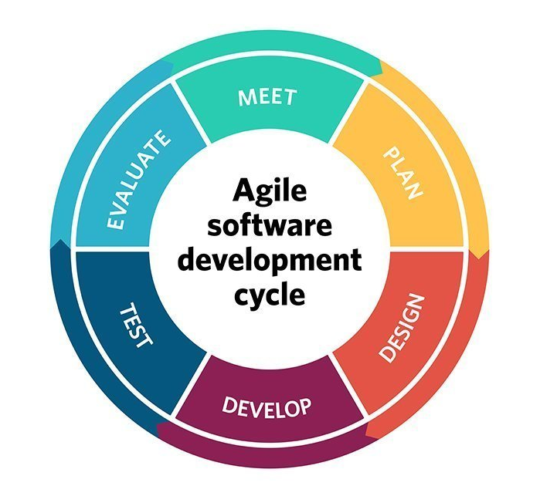

## 4.3 Gantt chart

Gannt chart is a type of horizontal bar chart which is used to show the time span of developing phase project. It shows a timeline, progress information and the relation of the tasks. It helps to make and coordinate the successful plan. It is very useful to determine whether the project is going on a right track or not. It helps to make plan for our project according to our need and requirements. In this Gantt chart starting and ending point is already declared. Time period of all the phase of system development lifecycle is declared which gives the clear idea about when the task should finish. In this project we are following agile development methodology so time of the project may extend in any time if user needs additional requirements in the system.

Gantt chart of Online Examination System

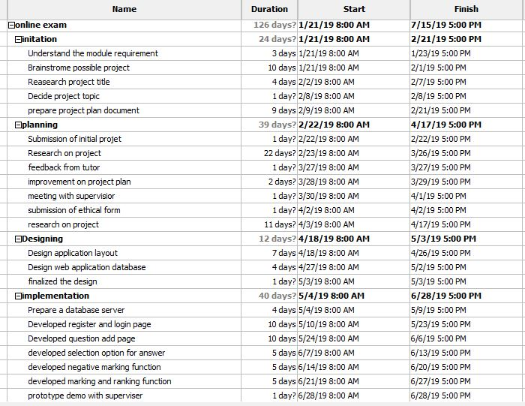

*Figure 1 List of tasks part 1*

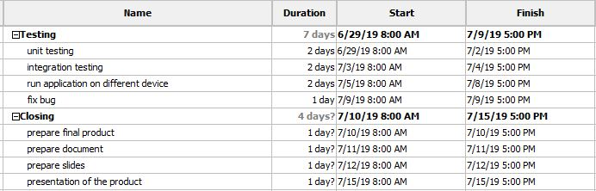

*Figure 2 List of tasks part 2*

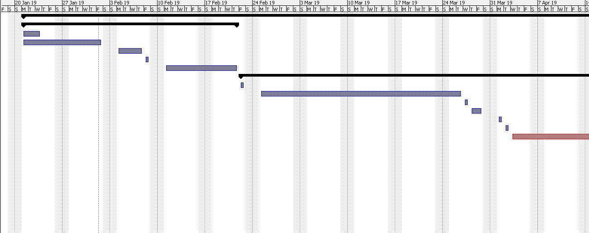

*Figure 3 Gantt chart part 1*

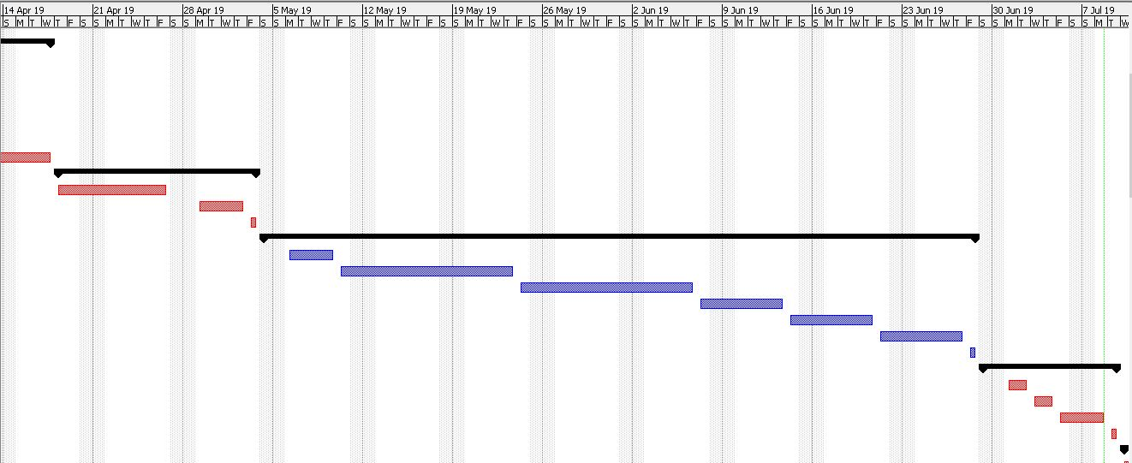

*Figure 4 Gantt chart part 2*

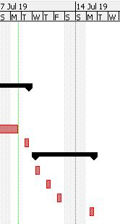

*Figure 5 Gantt chart part 3*

# Chapter 5: Design

Design is a key stage in software development life cycle. It includes architecture and algorithmic design of the system. It is an initial stage of project development which give us a clear vision about the structure, modules and interface of the system. In this project we are following agile design practiced method. This method starts from architectural designing of the system and ends with programming of the design. Architectural design identifies all modules and structure of the system that are related to each other. It provides a modular structure and relation between system and sub-system

Design is the face of any software system. Good Design of the system help the user to understand and run the system easily. Design of any system should be done by thinking as a normal user perspective because they do not understand a complex design. To developed ‘Online Examination system’ at first, we need to design initial model of the system. Flowchart use case diagram, data flow diagram and entity relationship diagram are basic initial model of the system. These architectural diagrams help to understand about the functionality of system. Diagrams are easy to understand by normal user. So, they can give feedback that need to change in the system.

## 5.1 Flow chart

Flow chart is the graphical representation of each step of algorithmic processes. Every step of the process is shown by different geometrical shapes and symbols. It shows a basic structure of the system and helps to understand the process flow of the system.

Flow chart of online examination system

Page-1

*Figure 6 Flowchart*

The above picture is the flow chart of ‘Online examination System’ which show the different process of the system. The system starts with the start terminator and ends with end terminator which is shown in oval flow chart shapes. Different process performed by system is shown in rectangular box. Add question and compute result are some process. Diamond flow chart shape indicate the decision-making process of the system. The parallelogram shape indicates the output data that we got from the system. In this system we get result of the exam as output. Lines in the chart show the connection and sequence of the processes. Detailed flowchart is provided in Appendix B

## 5.2 Entity Relationship Diagram

Entity relationship Diagram is a conceptual diagram which describes the structure of database. It consists an entity, attributes and relationship. Entity means anything that define table of the database. User, quiz, answer, feedback, history, option and rank are entities of the database table.

User table contains the registration and login details of the teacher and student. Quiz table contains the details of examination. Questions table is used to save the questions for the exam. Answer table is used to save answers of questions. Option table is use to save a selected option choose by student. History table is used to store the result. Rank table is used to show the rank of student in exam. Feedback table is used for storing feedback given by user.

All of these entities have their attributes. Relationship shows the relation between entities. Teacher can create a multiple quiz exam option for the student. They can add a many question for different subject title. Student can give a single subject exam at a time. Result and rank of the student published after exam is finished. Question table have a foreign key called ‘eid’ reference to table quiz. Quiz table have foreign key user email reference to user table. Answer table have multiple foreign key eid and qid reference to question table. History table is linked with multiples table. eid is foreign key reference to question table in history table. This ER-diagram is created using simple normalization forms.

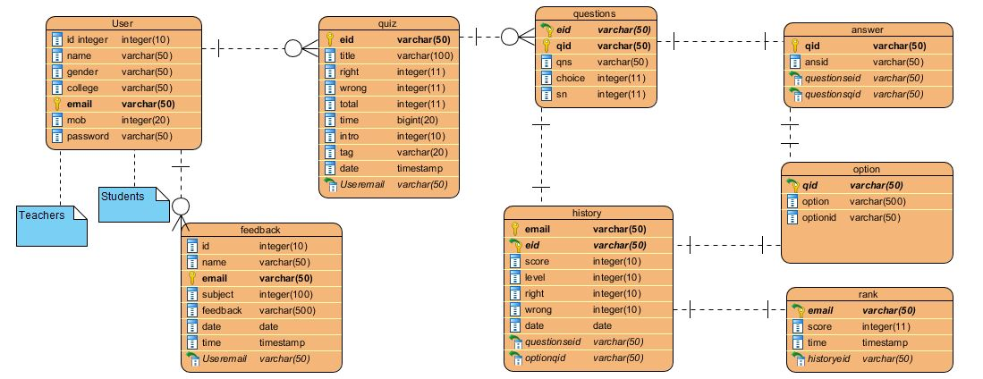

*Figure 7 Er-diagram*

## 5.3 Use case diagram

Use case diagram is the graphical representation of interaction between the elements of the system. It helps to identify and organized a requirement of the system. It shows the main function that user can performed in the system. It helps to identify the functionality of the system. It has four components actors, relationship, use cases and system boundary. Actors are those who performed actions in the system. Relationship describes the relation between use cases. Use cases are the list of functions that actor can performed. System boundary set the limitations of an action.

Use case diagram of ‘Online examination system’ is shown below. In this diagram Admin, teacher and student are the actor in the system. They performed their respective task in the system. Admin have control on the registration of the system. Teacher set the questions for the examinations and student can give the examination. After exam teacher can view the result and rank of the student. Student get their result immediately after exam and view their rank in the exam.

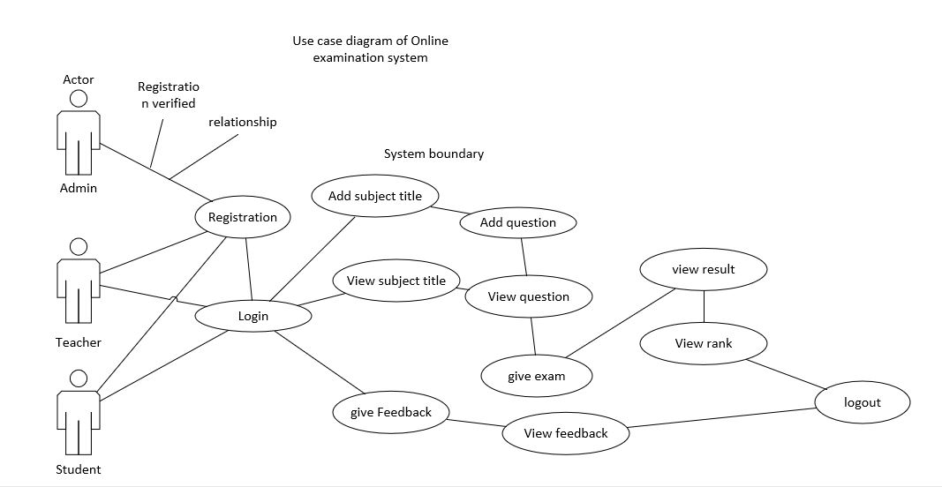

*Figure 8 use case diagram*

## 5.4 Data flow diagram

Data flow diagram is a type of diagram which is used to show the flow of data of the system. It gives us information about how all the data are processed and analyzed in the system. It is helpful for object-oriented design and development. DFD shows data flow, external entity, process, and stored data. It can be understood by non-technical people. It helps to understand a simple system to complex system.

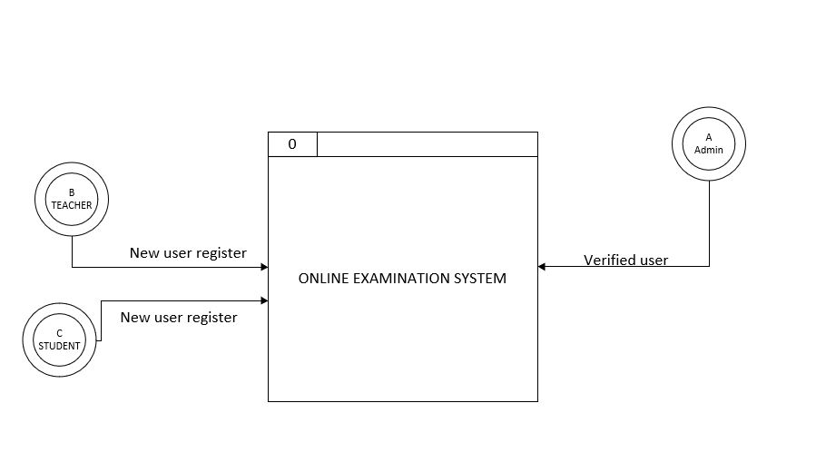

*Figure 9 DFD level 0 diagram*

Above diagram is the context diagram of ‘Online examination system’ which show the relationship of different external entities with the system. It is level 0 data-flow diagram which helps to clarify a boundary of the system where the data can flow. This diagram consists external entities, data flows, processes and data store. In this diagram teacher, admin and student are the external entities which is directly connected with the main system. Rectangular box is the database of the system. Curved lines show the flows of data in the system.

DFD level 1 diagram is shown below which gives the detailed information of different process of the system. Main processes breakdown into several sub-processes which makes easy to understand about the system. It helps to understand how the data flows in the system while performing different action by user. DFD level 1 diagram consist multiple number of data stores. All the database table are data store. In DFD diagram of ‘Online examination System’ User table, Quiz table, Question table, Answer table, option table, history table, rank table and feedback table are the data stores. Process are the main functions of the system. Add question, provide feedback, view result are some processes of examination system. Data flow line shows the flow of data in the system

Online Examination System DFD Level 1 diagram

Page-1

*Figure 10 DFD level 1 diagram*

# Chapter 6 Production Implementation and Testing

Software Testing means implementing a program to find out error and bug in the system. Bug can be found in coding and in the functionality. Testing can be functional and non-functional. Non- functional testing means testing done for the performance of the system. It helps to find out errors and missing hardware requirements for application in different environment. There are different types of testing approach to test the software programs. Selection of testing methods is depending on the resources, time, money, application type and data type of system. In agile software development methodology testing also done in iterative way. Testing is done in small portion of programs rather than a whole program. It helps to find out bugs in specific part of the program. Continues testing helps to get feedback from tester and we can fix the error continuously. Testing can be done in different phase of development lifecycle which helps to save time and money. Before testing verification of different functions is done by developer.

White box testing is done to test ‘Online examination System’. It is also known as open box testing which is used to test the internal structure and functionality of the system by the tester. It helps to find out error is specific part of the program and removed unnecessary part of code. Skilled tester tests this application who knows the internal functionality of the system. At first whole system break down into small unit. Important units are identified which need to check. After that line by line code of those unit is checked to find out bug. Bugs and errors reported to the developer to fix them. Tester gives feedback to improve GUI of application. Tester suggests make the application responsive for the mobile application. Testing is done continuously when new function is added to the application. If any error occurred, then debug is done. It also helps to optimized code.

Product implementation is the crucial part in System development lifecycle. It is the final time to execute the planning. It gives outcome of a plan. Successful product implementation depends upon the planning of the project. Proper planning of the project helps us to achieve goal easily. Hardware and software play important role in implementation of software. Required hardware and software need to implement properly to run the computer system properly. Successful deployment of any computer system required good configuration process and training of installing process. Implementation helps to monitor the system and helps to identify the problems in system. Changes in the system can be done if any problems occurred in the implementation.

For the proper implementation of ‘online examination System’ we need good internet service because it is a web-based application. Any changes in the system is updated through online. This application is browsing by using browser so it should support multiple browsers. Security of the web-application is major concern because it is surfing by using internet. In internet security of data is vital. Hacker can attack and damaged the system. Security protocols should be use in the system properly for secure implementation of the application. Data of the system is stored in remote server. Hyper Text transfer protocol is used for the web communication protocol.

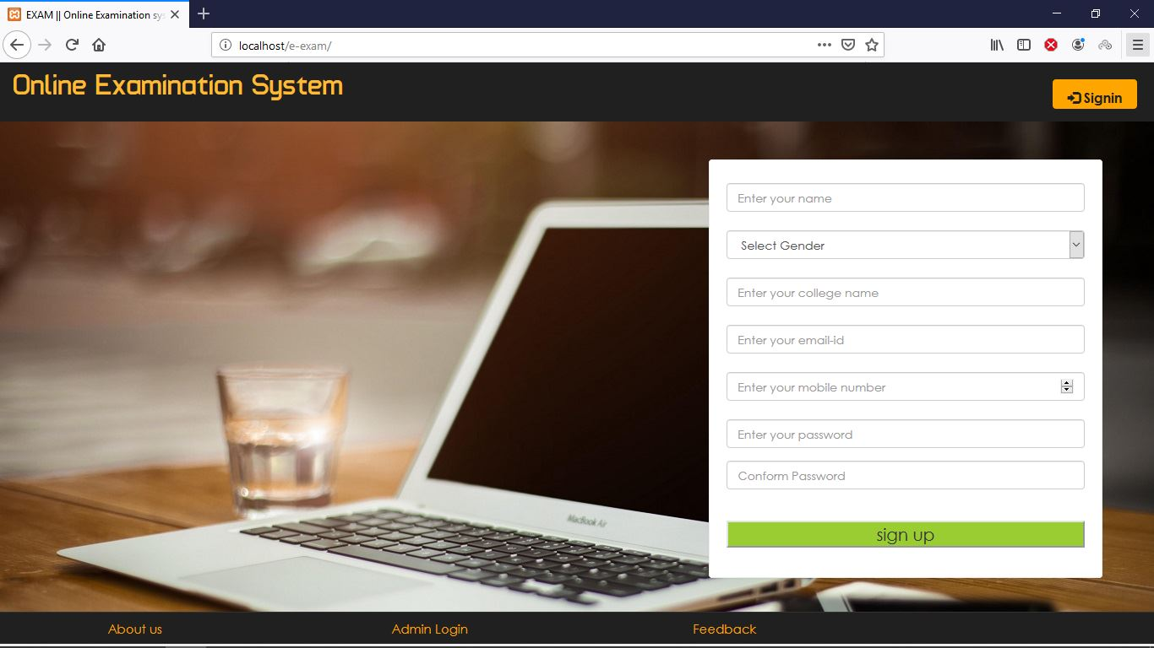

*Figure 11: Home page of online examination system*

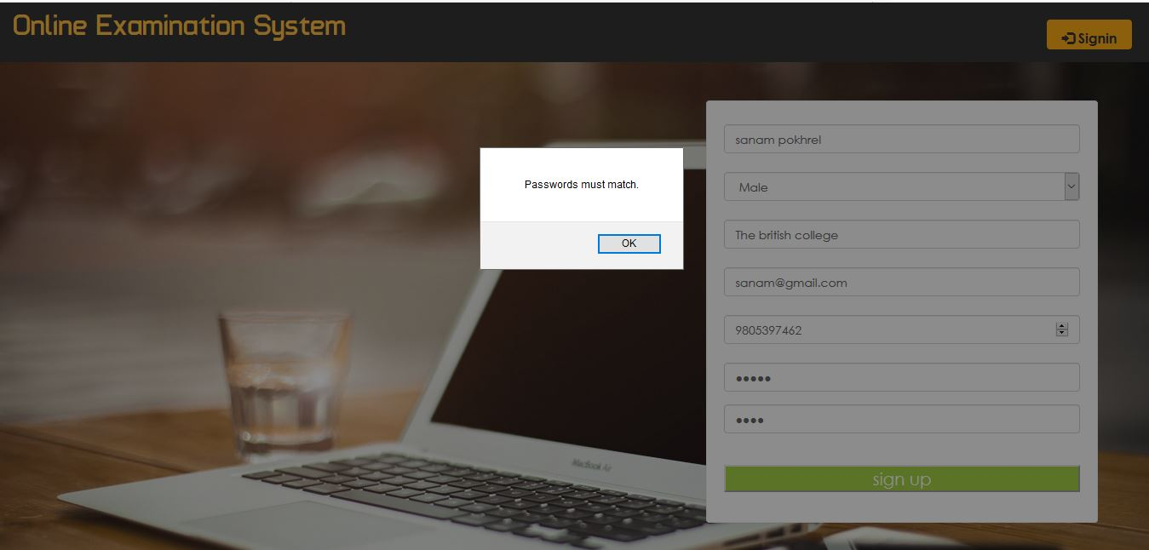

*Figure 12: User insert wrong conform password*

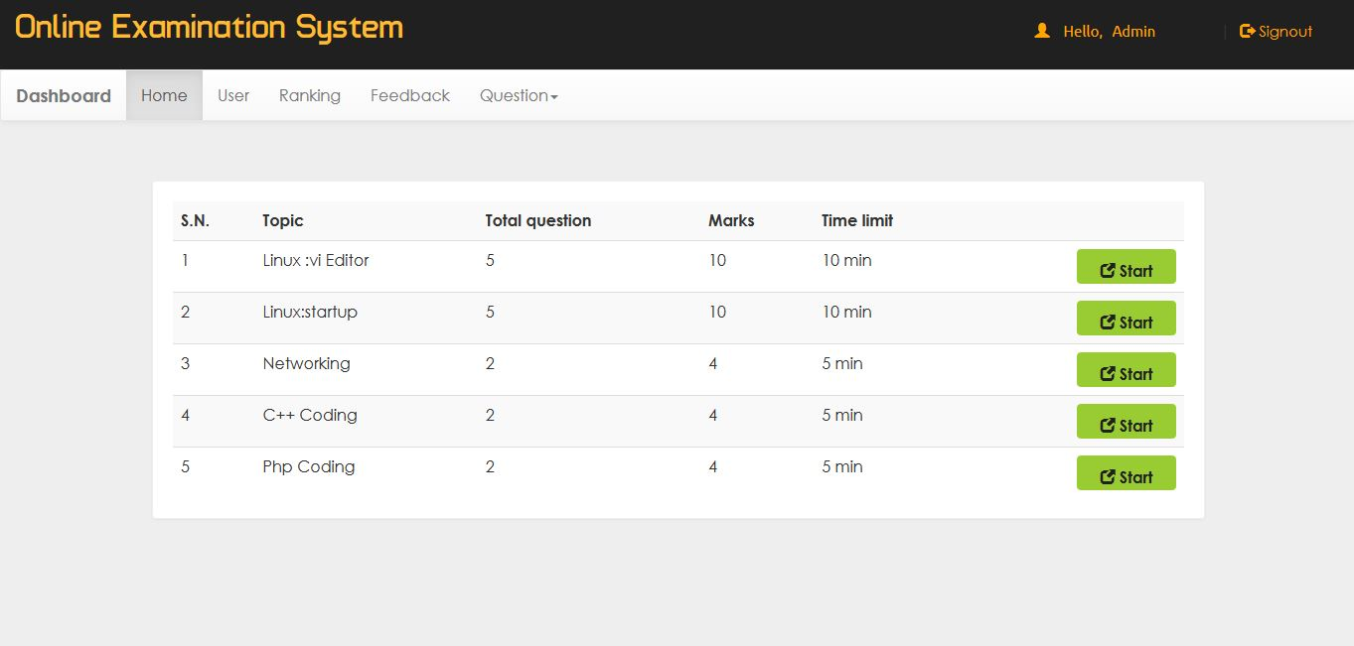

*Figure 13: Index page of admin with some questions is already added*

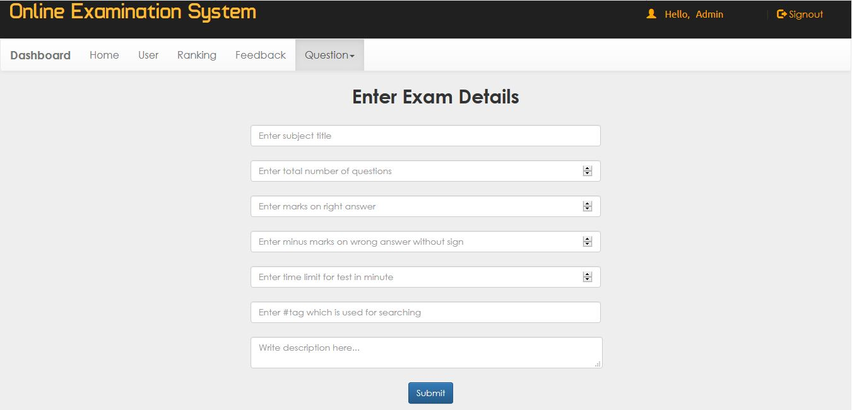

*Figure 14: Blank Exam details form*

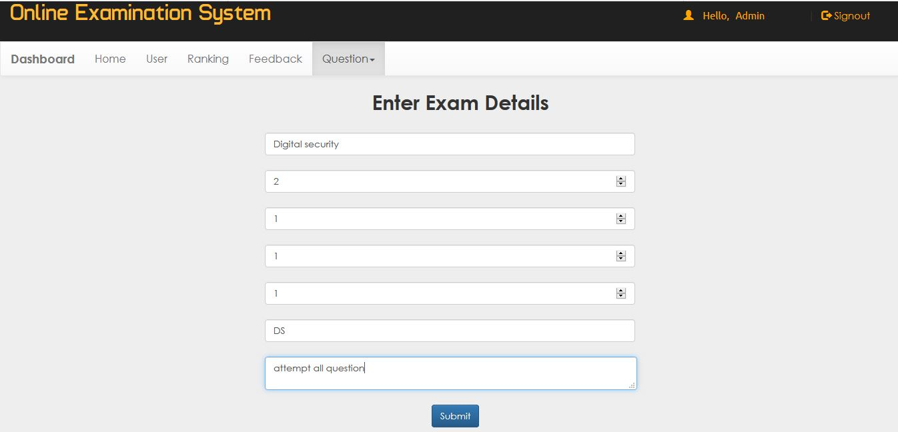

*Figure 15: Instructor insert exam details*

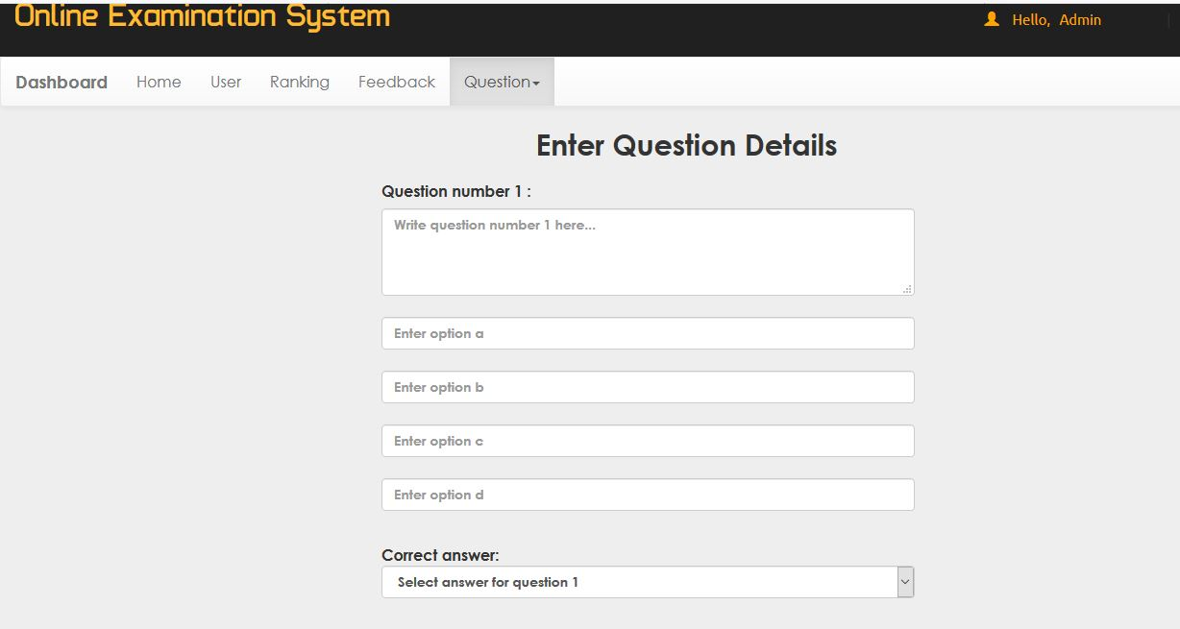

*Figure 16: Add questions forms*

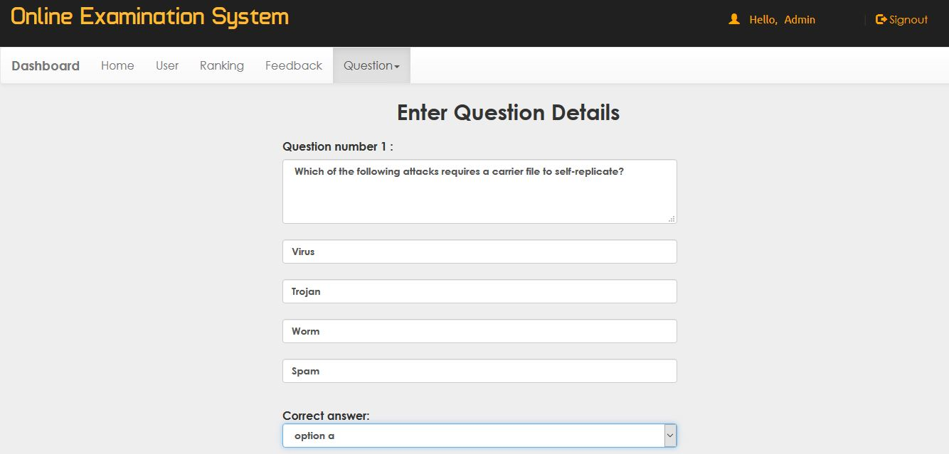

*Figure 17: Instructor adding questions*

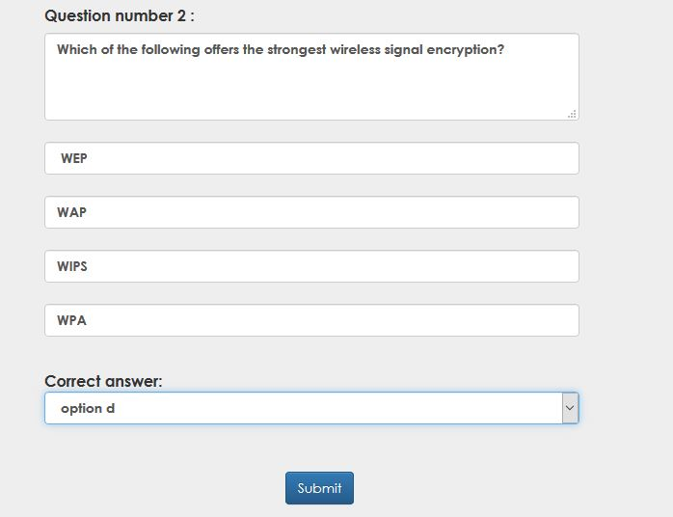

*Figure 18: Adding question by instructor*

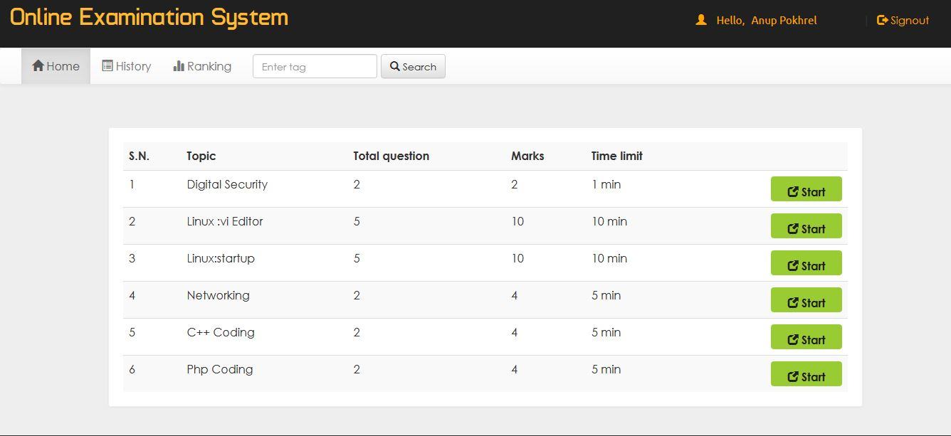

*Figure 19: Index page of student showing different subject*

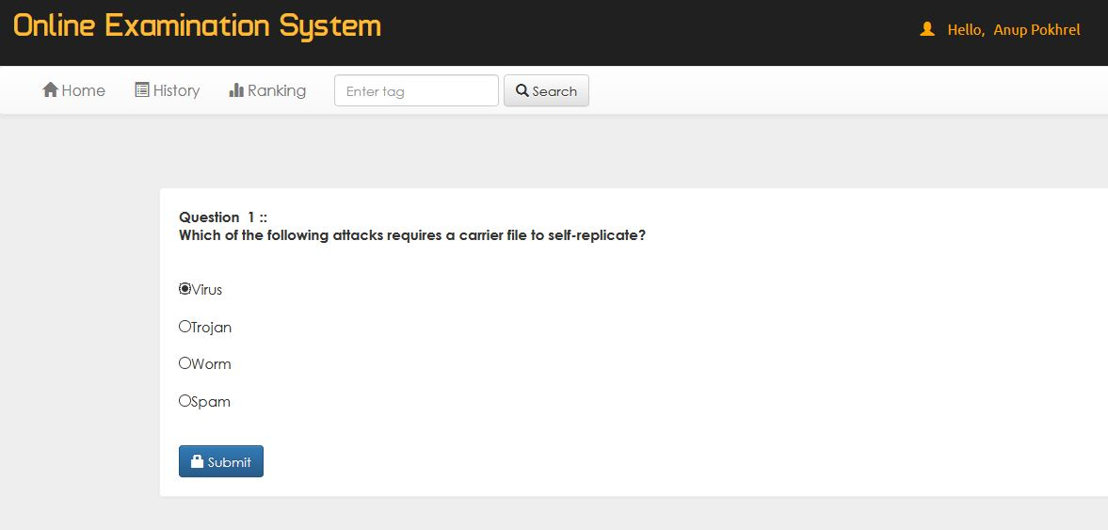

*Figure 20: Student giving exam*

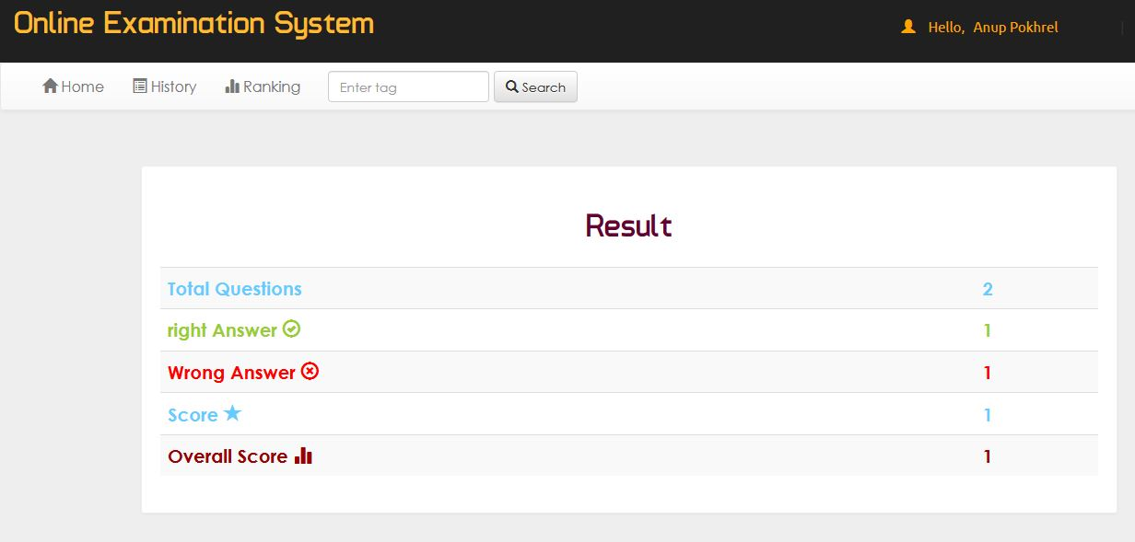

*Figure 21: Result of the exam*

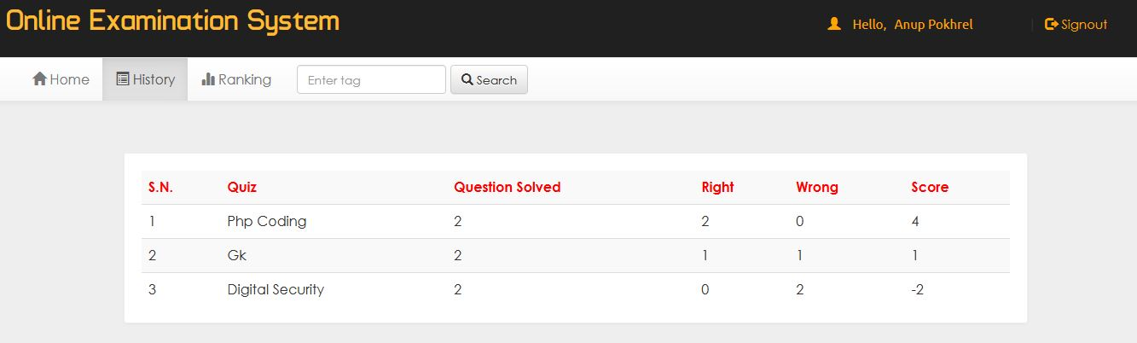

*Figure 22: Result of student in different subject*

# Chapter 7: Product evaluation and project management

Deployment and testing of the application are done successfully. Few errors found in the application in testing. Those errors are debug successfully. All the functions of the system run efficiently. MoSCoW rule is used to prioritized the requirements of the system. It helps to know the important features which is most required in the application. All the features which comes under must have requirement are properly developed and implemented.

Layout design of the system is simple. User feels easy to navigate the system. Design pattern is same like other examination system so, user does not confuse while using it. System is fully responsive so we can navigate from mobile phones easily. Using of navbar makes easy to navigate the system. It takes less time to navigate a system which ensure a good design. All the links and menus are shown properly in the navbar. Registration page help to register new user easily and login by using login log. Instructor can add new subject title and question with four selection options for one question. Important feature of this application is instructor can setup a negative marking for wrong selection of answer. Time for the examination can set in minutes. Another main feature of this application is it give a result immediately to students. Instructor can view the rank achieved by the student in the examination. There is a user page where all the details of student are listed. Search function is the system is introduced as a prototype that need to be revised and improved properly. History page provide a result of past examination attempt by the student. Specific objective listed in the plan of the project is implemented successfully. Research for the project is done, required data needed for the project are collected and analyzed properly. A proper plan is developed and design of the system is built. Object oriented programming language model is used to develop the product. OOP helps to add the functions and new methods in future if any changes is required in the system. Testing of the system is done, some errors is found in testing which is debug successfully.

Management of project is done by making a plan in Gantt chart. All the plans are listed and time is given for the task. More time is taken in development of the system so, some time is added in the middle of the project. Agile development methodology is followed which support iterative process in every phase of the development. To made the developing process faster whole project is separated in different small phase. This helps to make focus on development and easy to find out mistakes. Use case diagram, data flow diagram and entity relationship diagram provide a layout of the design. They provide idea to develop the system as requirement of user. We can make any changes in the future because agile supports iterative changes in the system. Problems is occurred to developed a marking function of answers. This function is developed later by consulting with the teacher. Different tutorials from the web is also studied to develop this function. Another bug is seen in negative marking function. Negative marks for the wrong answer are set 2 by instructor but the system provide only 1. These creates a huge problem it takes almost 2 weeks to debug this problem. Due to this problem time period for the project is increased.

System is fully tested by the expert. No big issues id found in the system. Expert evaluates the system by considering as an end-user. Suggestions are provided to add new features in the system to make it more user-friendly. Expert suggest to add more sub-links menus to reduce navigate time of the system. Another suggestion is to make search option more effective. Provide button up pointer to decrease the time of surfing.

# Chapter 8: Summery and conclusion

## 8.1 Summery

This report is the final document for this module. It provides information about the aim, objective and reason to select this topic. Objective helps to find out our main aim for this project. Literature review gives more knowledge and information for this project. It helps to understand the topic and developing own ideas for the project. Review of technology. Review of technology helps to select a suitable environment to developed the application. It provides a detailed information about the required technology which helps to developed a product successfully. Research methodology describe about the technique followed to get a data and information for the project. Data and information got from research is further analyzed and important data is selected for the project. This report gives a proper information about the Software Development lifecycle. It explains about a Software Development Methodology which is followed in this project. This report describes about each phase of Software Development Lifecycle. Design of the project is presented in different diagrams which helps to understand about the functionality of the system. This report explains how the product is implemented in real environment. It describes about the technology and environment needed to deploy the product. Technique of Software testing which is used to test the software is explained and well documented. Evaluation of the project is explained to carry out a pros and cons of project.

## 8.2 Findings

Research of this project help to understand about the problem of paper-based examination system. Paper-based examination system is expensive and time consuming. There is high chance of mis-judgement in the result of the student. Instructor can make error while checking exam paper which can make a student fail in exam. Sometime student gets more marks and less marks due to the error in marking. Paper based exam is not accessible for all student. Physically disable student especially those students whose hand is disable to write they cannot take part in paper-based examination system. Visual impairment students are excluded to take part in this examination system. A whole examination cycle is lengthy process it takes months to published result. Teacher cannot provide a feedback to the student immediately. Student did not get suggestions in time from teacher to make their study better in future. There are only few educational institutes which use Computer-based Test. Test is mostly done for the entrance examination of engineering and IT courses. Student finds easy to give such online exam than paper-based exam. It saves their time and gives them more chance to attempt all the questions in the exam. They got their result immediately after the exam and can get suggestion from teachers. Teachers can easily analyze a result and provide feedback.

There are some Online examination System which is practiced by different education institutes in different countries. System of Intelligent Evaluation using Tests for Tele-education, web-based Test, Examination and Assessment System, Exam Management System, Online Non-choice-based Examination System and Online Examination System in Bangladesh Context are some examination system used in different countries. All of these systems have problem of resumption capability which means any interruption in the system can stop the examination system. Any failure during the exam time force the student to give re-exam. Other finding from this project is as a developer I got to learn about object-oriented programming approach. It provides concept of encapsulation, inheritance, methods, function reusability of object and classes.

# 8.3 Conclusion and Recommendation

Software system need always improvements. Any flaws in the system can appear in any time so, we need to make changes in the system frequently. Online Examination System is ready to use but it has some flaws that need improvements. Software system always needs improvement. To make this system more convenient I will recommend some features that we can added in this system in future

* Allow student to edit their details
* Allow to instructor to generate a random question set for each student.
* Add features of Random question selection
* Add feature of Random Question distribution
* Improved search function
* Allow to take a subjective question examination
* Allow to add a graphical question in exam
* Add Tracking time that student take each question.
* Provide Resumption capability for any error occurred in the system so, student do not have to give re-exam. They could easily resume their exam without affecting time
* Add features to gather the statistics of student result which gives idea to make improvements in teaching and learning method.

This project provides a knowledge about Software Development Lifecycle. It helps to understand a different phase of software development. It teaches the importance of proper planning, designing and development of the system. Research help to understand the importance of online examination system over paper-based examination. Design of the application should be responsive and use-friendly. Testing of the system should start as soon as possible to minimized the flaws in the system. Testing should be done in multiple devices and platform to make the application available for more user. All the requirement of the system should manage properly before deployment. Evaluation of the system helps to understand pros and cons of the examination system

# Chapter 9: References

[***https://www.ittrainingnepal.com/php-project/online-examination-system/***](https://www.ittrainingnepal.com/php-project/online-examination-system/)

[**https://www.phptpoint.com/projects/online-examination/**](https://www.phptpoint.com/projects/online-examination/)

[**https://www.thinkexam.com/**](https://www.thinkexam.com/)

[**https://www.academia.edu/6729977/Online_Examination_System_because_examination_matters_Name_ALLAN_THATHI_NJERU**](https://www.academia.edu/6729977/Online_Examination_System_because_examination_matters_Name_ALLAN_THATHI_NJERU)

[**https://www.scientific.net**](https://www.scientific.net)

[**https://www.ukessays.com/essays/computer-science/overview-on-developing-an-online-examination-system-computer-science-essay.php**](https://www.ukessays.com/essays/computer-science/overview-on-developing-an-online-examination-system-computer-science-essay.php)

[**http://www.ijrcee.org/index.php/ijrcee/article/view/225**](http://www.ijrcee.org/index.php/ijrcee/article/view/225)

[**https://www.slideshare.net/fiu025/online-examination**](https://www.slideshare.net/fiu025/online-examination)

[**https://www.hcibook.com/e3-docs/slides/notes-pdf/e3-chap-09-6up.pdf/**](https://www.hcibook.com/e3-docs/slides/notes-pdf/e3-chap-09-6up.pdf/)

[**https://skillsforlearning.leedsbeckett.ac.uk/local/academic_communication/harvard_referencing/index.shtml/**](https://skillsforlearning.leedsbeckett.ac.uk/local/academic_communication/harvard_referencing/index.shtml/)

Younis, Mohammed & Hussein, Maysam. (2015). Construction of an Online Examination System with Resumption and Randomization Capabilities. International Journal of Computing Academic Research. 4. 62-82.

Conejo, Ricardo & Guzmán, Eduardo & Millán, Eva & Trella, Mónica & Pérez-de-la-Cruz, José-Luis & Ríos, Antonia. (2004). SIETTE: a Web-based tool for adaptive testing. I. J. Artificial Intelligence in Education. 14. 29-61.

R. Hameed, Muna & Abdullatif, Firas. (2017). Online Examination System. International Advanced Research Journal in Science, Engineering and Technology. 4. 106-110. 10.17148/IARJSET.2017.4321.

Yang X. (2013) The Research on Online Examination System of PE Theory Courses. In: Du Z. (eds) Proceedings of the 2012 International Conference of Modern Computer Science and Applications. Advances in Intelligent Systems and Computing, vol 191. Springer, Berlin, Heidelberg

Z. Yong-Sheng, F. Xiu-Mei and B. Ai-Qin, "The Research and Design of Online Examination System," 2015 7th International Conference on Information Technology in Medicine and Education (ITME), Huangshan, 2015, pp. 687-691.  
doi: 10.1109/ITME.2015.96  
keywords: {educational administrative data processing;Internet;SQL;online examination system;B/S mode;IDEA coding tool;MySQL database;user login;security authentication;question bank management;test paper management;Reactive power;Databases;Education;Encoding;Java;Authentication;System analysis and design;Web;the MySQL database;online examination},  
URL: <http://ieeexplore.ieee.org/stamp/stamp.jsp?tp=&arnumber=7429241&isnumber=7429072>

A Sarrayrih, M. and Ilyas, M. (2013). *Challenges of Online Exam, Performances and problems for Online University Exam*. 10th ed. [ebook] IJCSI International Journal of Computer Science Issues. Available at: http://www.IJCSI.org [Accessed 20 Jun. 2019].

Akanbi, C.O., & Adetunji, A.B (2012). An Online Essay-Based ExaminationAssessment Model Using Double Blind Marking Tecnique. African Journal of Computing and ICT, 5(6),104-108.

Ayo, C., Akinyemi, I., Adebiyi, A., & Ekong, U. (2007). The Prospects of E-Examination. Turkish Online Journal of Distance Education-TOJDE, 8(4),125-134

Burd, B. (2005). Beginning Programming with Java for Dummies,2nd ed. Indianapolis, Indiana: Wiley Publishing, Inc.Indianapolis, Indiana.Chen,D.J., Lai, A.F., & Liu, I.C. (2005). The Design and Implementati

Gardner, L., Sheridan, D., & White, D. (2002). A Web-based learning and assessment system to support flexible education. Journal of Computer Assisted Learning,18, 125–136.

Iyilade, J. S., & Odekunle, W. O. (2005). A Web-based Student Testing and Assessment System. Teaching, Research and Administration, AICTTRA, 1, 16-24

Olga D. R. (2004). Multilingual Graphical Authoring Editor in a Distributed e-Testing Cluster. Proceeding of Electronics’ 2004,Sozopol, Bulgaria.

Rashad, M. Z., Mahmoud S, K., Ahmed E, H., & Mahmoud A, Z. (2010). An Arabic Web-Based Examination. International Journal of Electrical & Computer Sciences,10(1), 48-54.

Wang, T. H., Wangw, K. H., W. L. Wangz, Huangz, S. C., & Chen, S. Y. (2004). Web-based Assessment and Test Analyses (WATA). Journal of Computer Assisted Learning,20, 59-71.

Zhaozong Meng & Joan Lu (2011). Implementing the Emerging Mobile Technology in Facilitating Mobile Exam System. Proceedings of 2nd International Conference on Networking and Information Technology, Singapore

A. S. Tanenbaum and M. V. Steen, “Distributed Systems Principles and Paradigms”, 2nd Edition,

Pearson Education, 2007.

L. Siyao and G. Qianrang, “The Research on Anti-Cheating Strategy of Online Examination

System”, Proceedings of the IEEE 2nd International Conference on Artificial Intelligence,

Management Science and Electronic Commerce (AIMSEC), Zhengzhou, China, pp. 1738-1741,

August 2011.

R. Sheshadri, T. C. Reddy, and N. A. kumar, “Web-Based-Secure Online Non-Choice-Based

Examination System (WONES) using Cryptography”, International Journal on Computer Science

and Engineering (IJCSE), Vol. 3, No. 10, pp. 3383-3393, October 2011.

P. G. Raj, P. Kumar, S. Sengupta, K. Vats, and P. R. Gupta, “An Architectural Insight into the

National Online Examination System”, International Journal of e-Education, e-Business, e-

Management and e-Learning, Vol. 2, No. 2, pp. 126-131, April 2012.

# APPENDIX A: PROJECT PLAN

|  |  |  |
| --- | --- | --- |
| **BSc (Hons) Computing Course 2018/19**  **Level 6 Production Project** | | |
| **Name: Anup pokhrel** | **Student I.D.: c7193454** | |
| **Course: BSc (Hons) Computing** | **Supervisor’s Name:**  **Pranita Upadhyaya** | |
| **FINAL PROJECT INDIVIDUAL AIM & OBJECTIVES** | | |
| **Title of my Project:**  Online Examination system | | |
| **Aim of my Final Project:**  Aim of the project is to develop a web-based application that helps to take an online exam of student | | |
| **Objectives of my Final Project:**   * To do research and explore about the Education and Examination system of Nepal. * To design a responsive web-application. * To develop online examination system * To test a different functionality of the system. * To make the examination system more effective and increase the efficiency. * To saves people money and time. * To learn about the problems in traditional examination system * To document a project report in structured way. | | |
| **Specification of my Final Product:**  The Site will have these Moscow specifications;  **Must have**   * Responsive and user-friendly design * User registration, login and logout * Proper validation of registration form * Admin Panel * Add, delete view questions * Selection of subject * Selection of answers * Marking of answer * Ranking of student * Negative marking for wrong answer * Publishing result   **Should have**   * Random selection of questions * Random distribution of question * Timer * Proper validation in selection of answer * Multiple instructor function   **Could have**   * Subjective questions examination * Tracking time that student take for each question * Re-setting password * Proper search functions | | |
| **Research**  **Research title=** Online Exams: Practical Implications and Future Directions  **Outline of my research=**  Research should be done in various field for this project. We should research on how the operation of exam system should run. We should focus on its efficiency and effectiveness. It is a web-based application so, we should focus on its responsiveness, easy user control, navigation and easy surfing. After research it was found that a good database system in essential to make the project successful. MYSQLI is the suitable database server for this project. PHP programming language is very useful to developed a web-application because it supports MYSQL database | | |
| **Methods of Production Evaluation**  *A description of the method of product evaluation (100 words max).*  Expert analysis evaluation method is used in this project to evaluate the product. Expert is directly involved in this project to give suggestion and feedback. Expert helps to test the usability, performance, consistency, cost of the product based on heuristics evaluation technique. It provides the speedy feedback to the developers and designers. It helps to maintain errors and keep the standard of the product. Expert evaluates system based on a cognitive principal. It helps to find out the bugs in the user interface and to find out the usability errors in the system. Expert is directly involved in the project so; they know about the internal functionality of whole systems. They help us to develop a proper well functional system by using optimized code. | | |
|  | | |
| Project Planning  *A one-page Gantt chart showing timing of different phase of project*            **Methodology**  *Which Methodology you are planning to follow and why? Give description. (such as waterfall, agile development methodology etc.)*  Agile Development Methodology is followed in this project because this methodology is iterative, efficient and flexible. It provides a good customer satisfaction and collaboration with the customer. Chances of project failure is very low in this development methodology. It helps to develop the product in given time. Agile allows the changes in project in any time as user required. In this methodology product is delivered in a multiples phase to the user in different interval of time. It helps to get feedback from customers time and again. Agile helps to estimate the total cost and time required for the project. It helps to carry out the progress speed of each development team. | | |
| **PHYSICAL RESOURCE** | | |
| **The hardware and software I require to complete my Project successfully:** | | |
| Item (Hardware or Software) | | Source ***(Faculty, own or specified another organisation)*** |
| * Dell Laptop | | OWN |
| * (Sublime text editor) | | OWN |
| * Xampp | | OWN |
| * Microsoft package | | OWN |
| * **Project libre** | | own |
|  | |  |
|  | |  |
|  | |  |
|  | |  |

|  |  |
| --- | --- |
| **HUMAN RESOURCE** | |
| **I am working on my Project with the following people** *[list any others involved including your client, your supervisor (not known at the time you submit your Initial Project Plan), those supplying ideas, feedback or evaluation, users of your product, other students (if you are in a team). Delete or add rows as necessary].* | |
| **Name 1:**  **Dr pranita upadhyaya** | Role: Module Leader |
| The British College Staff |
|  | |
| **INITIAL BIBLIOGRAPHY** | |
| *[Include a list, in Leeds Beckett Harvard format, of 10 authoritative references which can later form the basis of your literature review. You can include more sources if you like to help justify the project and product specification. Remember to cite references from the main body of the project plan, where appropriate. For a guide to the correct format to use see -]*  [***https://www.ittrainingnepal.com/php-project/online-examination-system/***](https://www.ittrainingnepal.com/php-project/online-examination-system/)  [**https://www.phptpoint.com/projects/online-examination/**](https://www.phptpoint.com/projects/online-examination/)  [**https://www.thinkexam.com/**](https://www.thinkexam.com/)  [**https://www.academia.edu/6729977/Online_Examination_System_because_examination_matters_Name_ALLAN_THATHI_NJERU**](https://www.academia.edu/6729977/Online_Examination_System_because_examination_matters_Name_ALLAN_THATHI_NJERU)  [**https://www.scientific.net**](https://www.scientific.net)  [**https://www.ukessays.com/essays/computer-science/overview-on-developing-an-online-examination-system-computer-science-essay.php**](https://www.ukessays.com/essays/computer-science/overview-on-developing-an-online-examination-system-computer-science-essay.php)  [**http://www.ijrcee.org/index.php/ijrcee/article/view/225**](http://www.ijrcee.org/index.php/ijrcee/article/view/225)  [**https://www.slideshare.net/fiu025/online-examination**](https://www.slideshare.net/fiu025/online-examination)  [**https://www.hcibook.com/e3-docs/slides/notes-pdf/e3-chap-09-6up.pdf/**](https://www.hcibook.com/e3-docs/slides/notes-pdf/e3-chap-09-6up.pdf/)  [**https://skillsforlearning.leedsbeckett.ac.uk/local/academic_communication/harvard_referencing/index.shtml/**](https://skillsforlearning.leedsbeckett.ac.uk/local/academic_communication/harvard_referencing/index.shtml/) | |

# APPENDIX B: DETAILED FLOW CHART

Flowchart of add question and answer



Flowchart of giving exam



# APPENDIX C: EVIDENCE OF RESEARCH

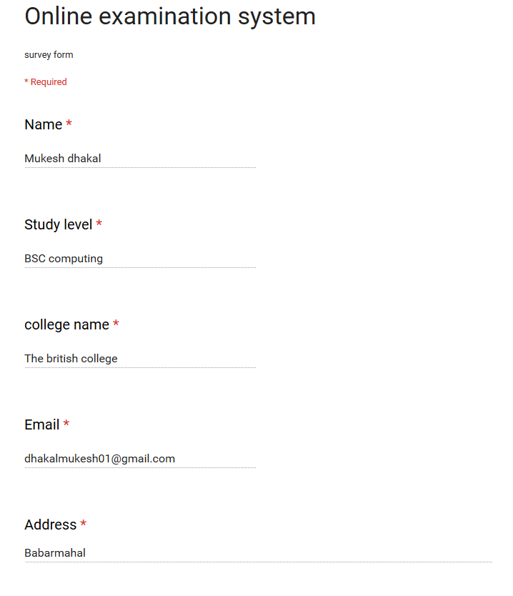

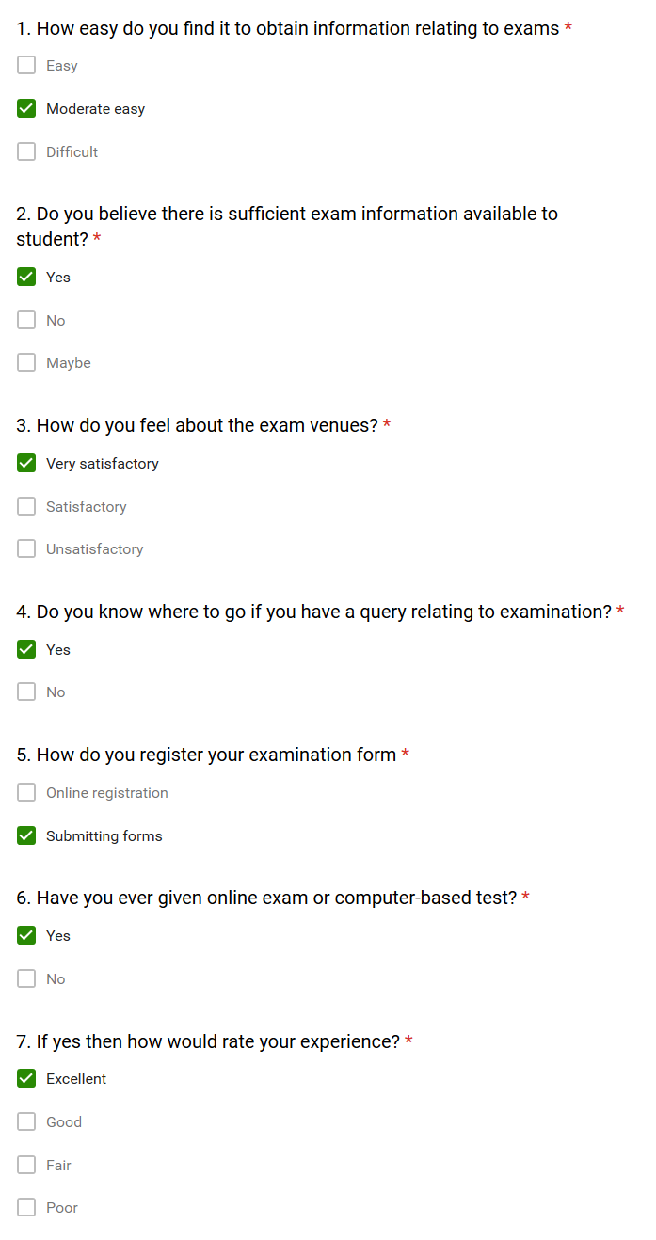

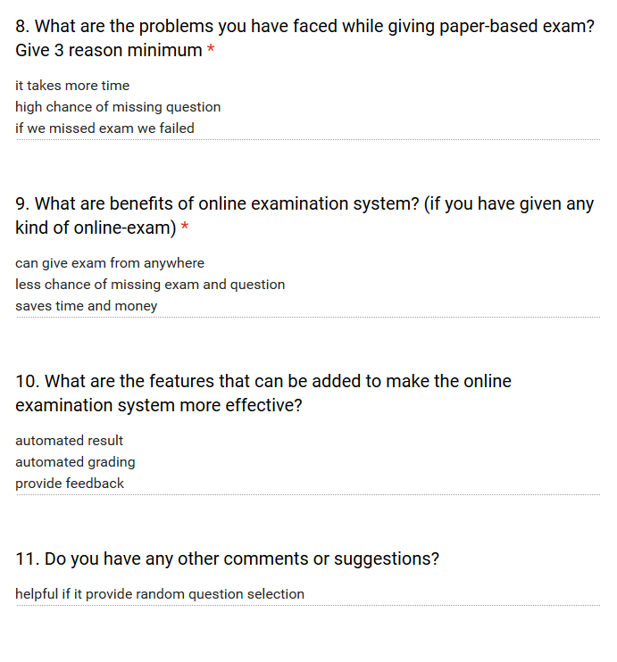

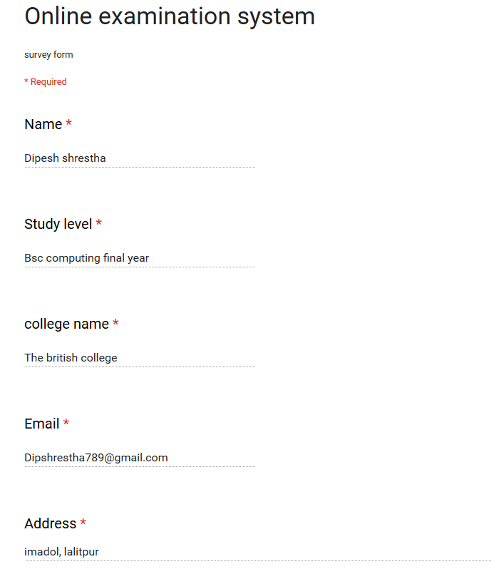

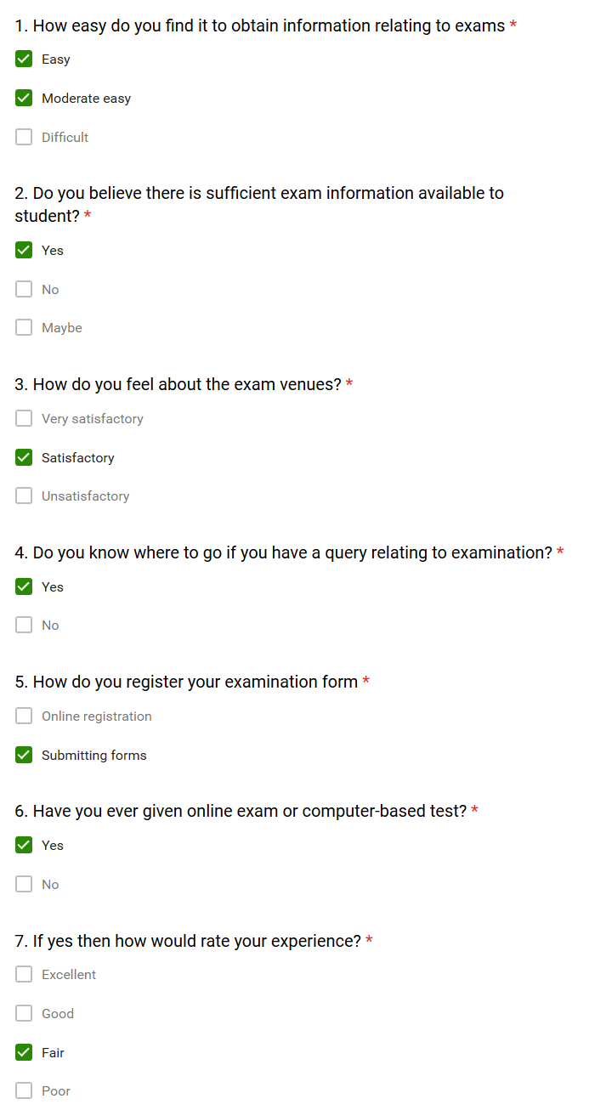

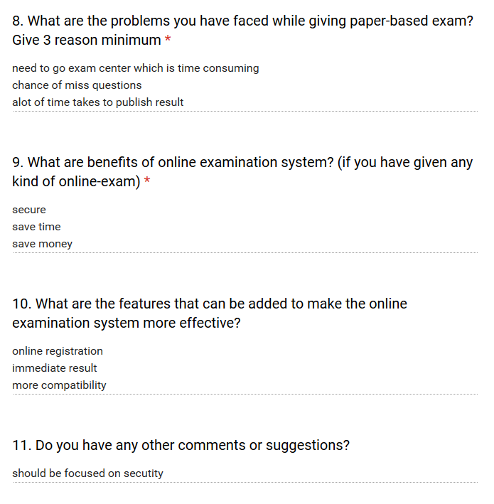

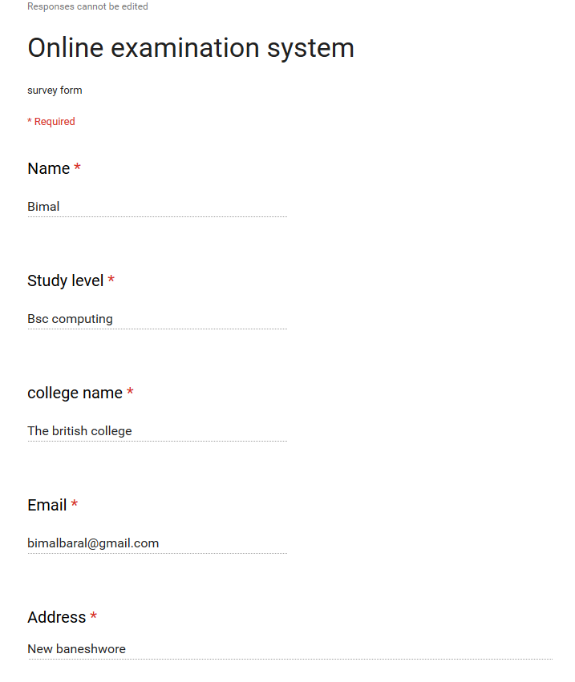

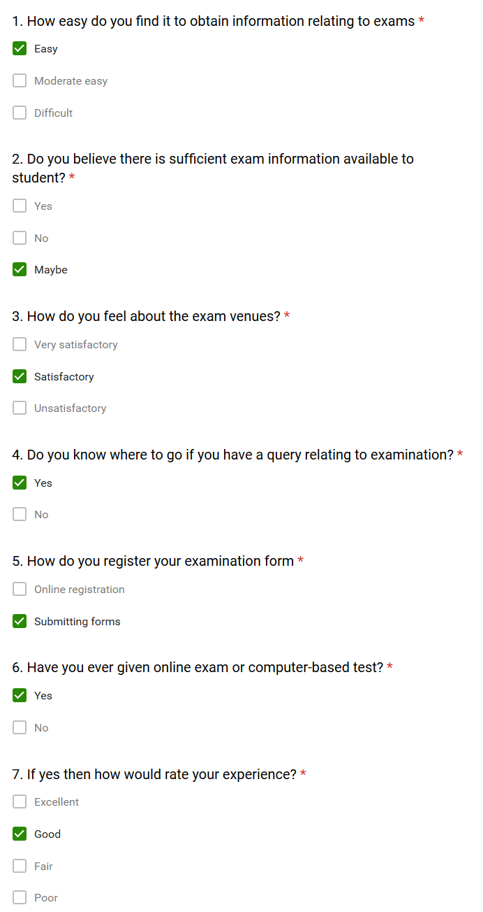

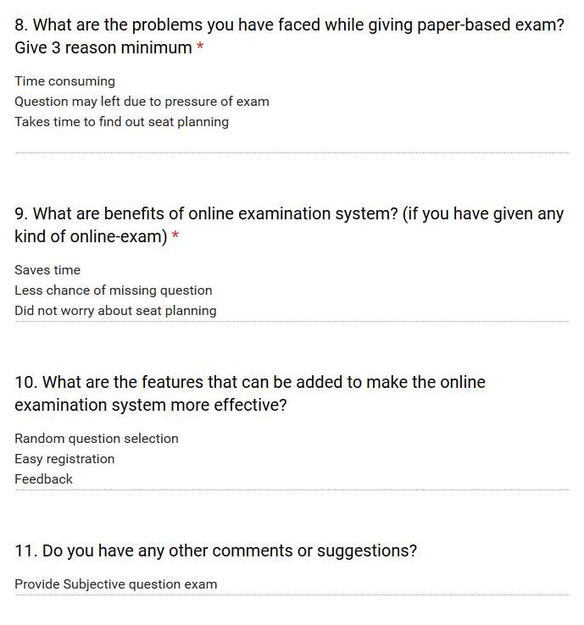

# APPENDIX D: EVIDENCE OF PROJECT MANAGEMENT

|  |  |  |  |
| --- | --- | --- | --- |
| **School of Computing, Creative Technologies and Engineering 2019**  **Level 6 Production Project** | | | |
| **MEETING RECORD SHEET:** | | | **Meeting**  **Number:1** |
| **Student: Anup pokhrel** | | **Student I.D.:77193454** | |
| **Date of Meeting:1st May 2019** | | **Supervisor: Pranita Upadhyay** | |
| **Actions agreed at previous meeting (completed or comment):** | | | |
| **1** | **Agreed on the title √** | | |
| **2** | **Gathered information about e-commerce and gas business √** | | |
| **3** | **Improved objectives√** | | |
| **Comments of student (if any)**………................. | | | |
| ***ABOVE here*** *– student to complete before Meeting with supervisor.* ***BELOW here*** *– complete at the Meeting.* | | | |
| **Next meeting** (date/time)**:10th May 2019** | | | |
| **Agreed Actions to complete before next meeting:** | | | |
| **1** | **Collect research papers** | | |
| **2** | **Make concept of design** | | |
| **3** | **Make concept of application working process** | | |
| **4** | **Design the layout** | | |
| **5** | **Design database table** | | |

|  |  |  |  |
| --- | --- | --- | --- |
| **School of Computing, Creative Technologies and Engineering 2019**  **Level 6 Production Project** | | | |
| **MEETING RECORD SHEET:** | | | **Meeting**  **Number:2** |
| **Student: Anup pokhrel** | | **Student I.D.:77193454** | |
| **Date of Meeting: 10th may 2019** | | **Supervisor: Pranita Upadhyay** | |
| **Actions agreed at previous meeting (completed or comment):** | | | |
| **1** | **Collect research papers√** | | |
| **2** | **Make concept of design √** | | |
| **3** | **Make concept of application working process √** | | |
| **4** | **Design the layout√** | | |
| **5** | **Design database table√** | | |
| **6** |  | | |
| **Comments of student (if any)**………................. | | | |
| ***ABOVE here*** *– student to complete before Meeting with supervisor.* ***BELOW here*** *– complete at the Meeting.* | | | |
| **Next meeting** (date/time)**:20th may 2019** | | | |
| **Agreed Actions to complete before next meeting:** | | | |
| **1** | **Fill the ethical form** | | |
| **2** | **Submit ethical form** | | |
| **3** | **Complete the database design** | | |
| **4** | **Design ERD and other diagrams** | | |
| **Comments of supervisor (if any):** | | | |

|  |  |  |  |
| --- | --- | --- | --- |
| **School of Computing, Creative Technologies and Engineering 2019**  **Level 6 Production Project** | | | |
| **MEETING RECORD SHEET:** | | | **Meeting**  **Number:3** |
| **Student: Anup pokhrel** | | **Student I.D.:77193454** | |
| **Date of Meeting: 20th May 2019** | | **Supervisor: Pranita Upadhyay** | |
| **Actions agreed at previous meeting (completed or comment):** | | | |
| **1** | **Fill the ethical form √** | | |
| **2** | **Submit ethical form √** | | |
| **3** | **Complete the database design√** | | |
| **4** | **Design ERD and other diagrams √** | | |
| **5** |  | | |
| **6** |  | | |
| **Comments of student (if any)**………................. | | | |
| ***ABOVE here*** *– student to complete before Meeting with supervisor.* ***BELOW here*** *– complete at the Meeting.* | | | |
| **Next meeting** (date/time)**:1st June 2018** | | | |
| **Agreed Actions to complete before next meeting:** | | | |
| **1** | **Changes should be made in diagrams and ERD** | | |
| **2** | **Report writing should be started** | | |
| **3** | **Development of the product should be shown** | | |
| **Comments of supervisor (if any):** | | | |

|  |  |  |  |
| --- | --- | --- | --- |
| **School of Computing, Creative Technologies and Engineering 2019**  **Level 6 Production Project** | | | |
| **MEETING RECORD SHEET:** | | | **Meeting**  **Number:4** |
| **Student: Anup pokhrel** | | **Student I.D.:77193454** | |
| **Date of Meeting: 1st june 2019** | | **Supervisor: Pranita Upadhyay** | |
| **Actions agreed at previous meeting (completed or comment):** | | | |
| **1** | **Changes should be made in diagrams and ERD √** | | |
| **2** | **Report writing should be started √** | | |
| **3** | **Development of the product should be shown √** | | |
| **Comments of student (if any)**………................. | | | |
| ***ABOVE here*** *– student to complete before Meeting with supervisor.* ***BELOW here*** *– complete at the Meeting.* | | | |
| **Next meeting** (date/time)**:20th June 2019** | | | |
| **Agreed Actions to complete before next meeting:** | | | |
| **1** | **setup database** | | |
| **2** | **Finalize the design** | | |
| **3** | **Start development of functions and features** | | |
| **Comments of supervisor (if any):** | | | |

|  |  |  |  |
| --- | --- | --- | --- |
| **School of Computing, Creative Technologies and Engineering 2019**  **Level 6 Production Project** | | | |
| **MEETING RECORD SHEET:** | | | **Meeting**  **Number:5** |
| **Student: Anup pokhrel** | | **Student I.D.:77193454** | |
| **Date of Meeting: 20th June 2019** | | **Supervisor: Pranita Upadhyay** | |
| **Actions agreed at previous meeting (completed or comment):** | | | |
| **1** | **Database is setup successfully√** | | |
| **2** | **Design is complete√** | | |
| **3** | **Development of function and features is started√** | | |
| **Comments of student (if any)**………................. | | | |
| ***ABOVE here*** *– student to complete before Meeting with supervisor.* ***BELOW here*** *– complete at the Meeting.* | | | |
| **Next meeting** (date/time)**:1st July 2019** | | | |
| **Agreed Actions to complete before next meeting:** | | | |
| **1** | **Add new features in the system** | | |
| **2** | **Use proper validation in registration form** | | |
| **3** | **Add more reference and citation in report** | | |
| **4** | **Start testing of the product** | | |
| **5** | **Complete the development of product** | | |
| **Comments of supervisor (if any):** | | | |

|  |  |  |  |
| --- | --- | --- | --- |
| **School of Computing, Creative Technologies and Engineering 2019**  **Level 6 Production Project** | | | |
| **MEETING RECORD SHEET:** | | | **Meeting**  **Number:6** |
| **Student: Anup pokhrel** | | **Student I.D.:77193454** | |
| **Date of Meeting: 1st July 2019** | | **Supervisor: Pranita Upadhyay** | |
| **Actions agreed at previous meeting (completed or comment):** | | | |
| **1** | **New features are added in the system√** | | |
| **2** | **Proper validation is done√** | | |
| **3** | **More references are added in the report√** | | |
| **4** | **Testing is done√** | | |
| **5** | **Complete product development√** | | |
| **Comments of student (if any)**………................. | | | |
| ***ABOVE here*** *– student to complete before Meeting with supervisor.* ***BELOW here*** *– complete at the Meeting.* | | | |
| **Next meeting** (date/time)**:10th July 2019** | | | |
| **Agreed Actions to complete before next meeting:** | | | |
| **1** | **Improve report format** | | |
| **2** | **Fixed bug** | | |
| **3** | **Implement the system properly** | | |
| **Comments of supervisor (if any):** | | | |

|  |  |  |  |
| --- | --- | --- | --- |
| **School of Computing, Creative Technologies and Engineering 2019**  **Level 6 Production Project** | | | |
| **MEETING RECORD SHEET:** | | | **Meeting**  **Number:7** |
| **Student: Anup pokhrel** | | **Student I.D.:77193454** | |
| **Date of Meeting: 10th J 2019** | | **Supervisor: Pranita Upadhyay** | |
| **Actions agreed at previous meeting (completed or comment):** | | | |
| **1** | **Bug are fixed properly√** | | |
| **2** | **Report is improved and managed√** | | |
| **3** | **System is implemented properly√** | | |
| **Comments of student (if any)**………................. | | | |
| ***ABOVE here*** *– student to complete before Meeting with supervisor.* ***BELOW here*** *– complete at the Meeting.* | | | |
| **Next meeting** (date/time)**:13th July 2019** | | | |
| **Agreed Actions to complete before next meeting:** | | | |
| **1** | **Complete report** | | |
| **2** | **Prepare slides for presentation** | | |
| **Comments of supervisor (if any):** | | | |

# APPENDIX E: USER GUIDE

USER GUIDE TO ADD EXAM DETAILS, ADD QUESTIONS AND GIVE EXAMINATION



The above picture is the form where teacher can add the details of the exam. All the fields of the form should fill properly. Subject titles for the exam, number of total questions, marks for right answer for each question, negative marking for no answer, time limit for the exam and description properly.



The above picture is the form of adds questions. Teacher can add the question in that form. First form field is for question and other four for to add answer. Drop down menu is for selecting a right answer of a question.



The above screens show how to choose an answer of a question. One question has four multiple choice answer. Student have to choose 1 answer of a question. After completing exam result is published immediately.

# APPENDIX F: EVEIDENCE OF PRODUCT TESTING



*Testing for wrong input of conform password*



*Testing to add exam details*



*Testing to add question*



*Questions are added successfully*



*Testing for giving exam*



*Result is provided by system successfully*

# APPENDIX G: PRESENTATION SLIDES

